**Name: Nguyen Minh Nhut – 518H0545**

**Exercise 1:**

You have been asked to develop a system that will help with **planning large-scale events and parties** such as weddings, graduation celebrations, birthday parties, etc.

Using an activity diagram, model the process context for such a system that shows the activities involved in **planning a party** (booking a venue, organizing invitations, etc.) and the system elements that may be used at each stage

**User story:**

* I click on party order button -> System returns party registry form -> System returns party type selector
* I pick a party type -> System suggest party type’s appropriate price
* I select party budget -> System save customer’s price -> Set available date for particular party type, budget.
* I choose a party/event date -> System save customer’s date -> System returns list of locations
* I choose a location -> System save customer’s location choice -> System returns input for number of participants
* I estimate number of people -> System check if it is enough space or budget to start transaction or not -> Return payment detail when everything is OK
* I choose to pay or quit it -> System verifies payments, make report and then send it to vendor

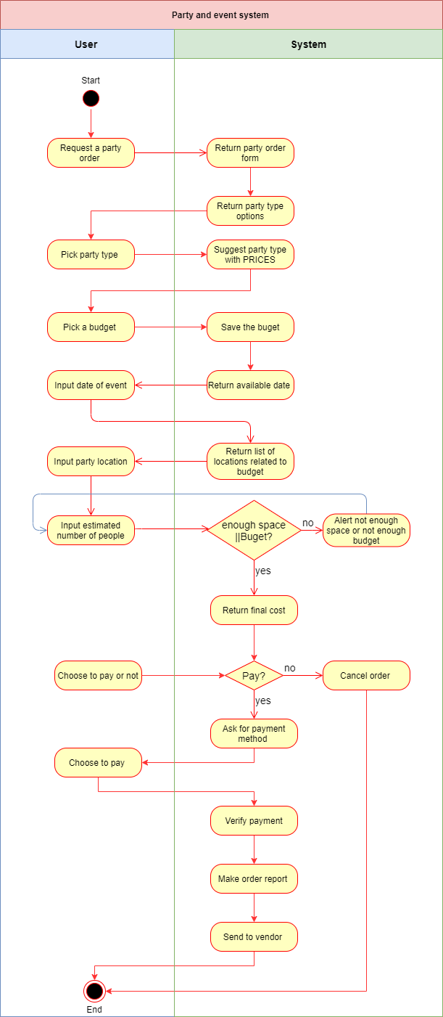

**Exercise 2:**

Look carefully at how messages and mailboxes are represented in the e-mail system that you use.

Model the object classes that might be used in the system implementation to represent a mailbox and an e-mail message

**<<Mail message>>**  
Attributes: *Sender, receiver list, cc list, bcc list, date, subject, message body, attachments, signature*Behaviors: *read, reply, reply all, print, forward, send*  
  
**<<Mailbox>>**  
Attributes: *Name, pathname, creation date, change date, messages, unread messages deleted messages*Behaviors: *move message, copy message, delete message, create, rename, delete*

**Exercise 3:**

Based on your experience with a bank ATM, draw an activity diagram that models the data processing involved when a customer withdraws cash from the machine.

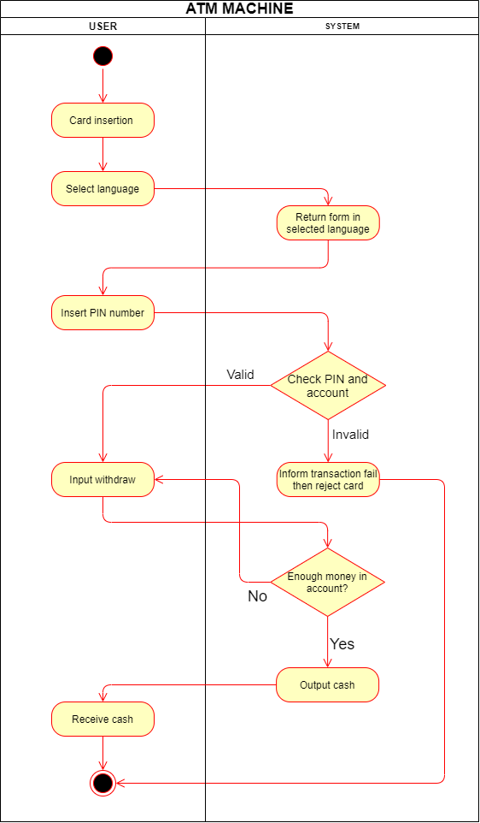

**Exercise 4:**

Draw state diagrams of the control software for:

* An automatic washing machine that has different programs for different types of clothes.

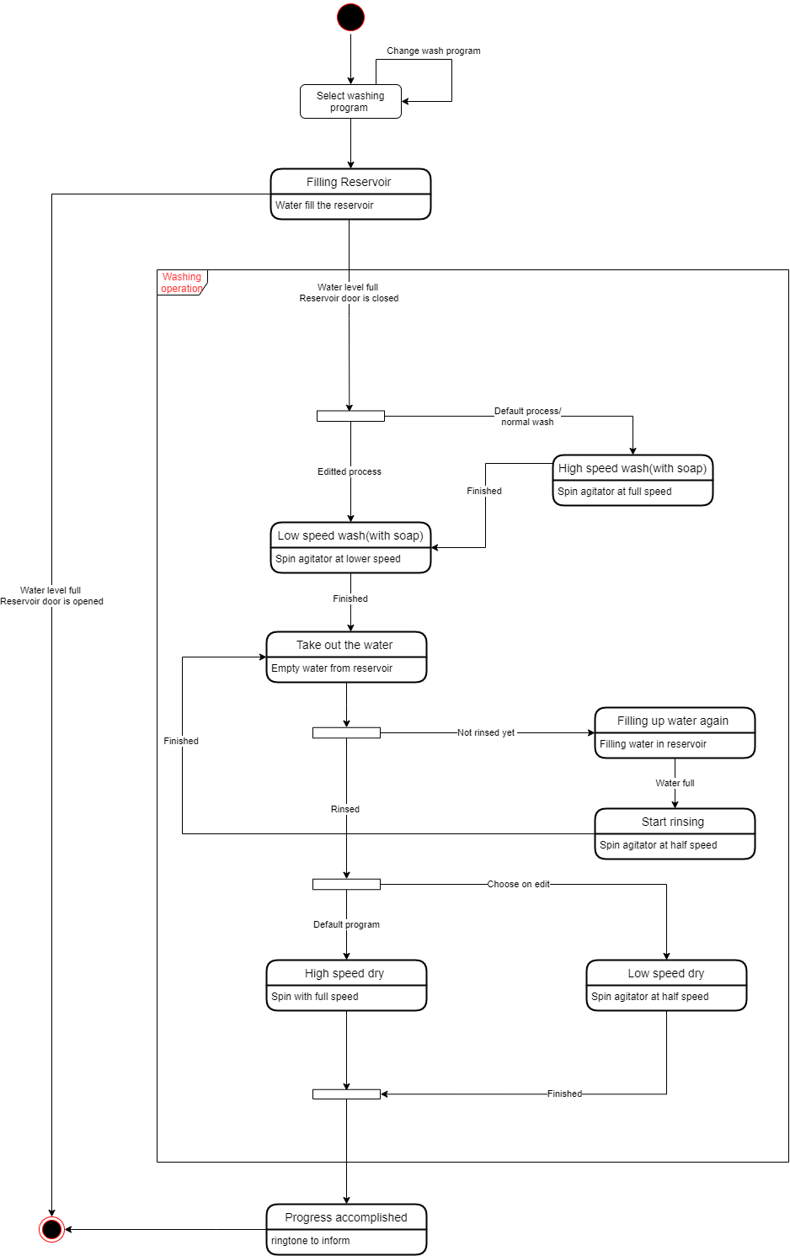

* The software for a DVD player.

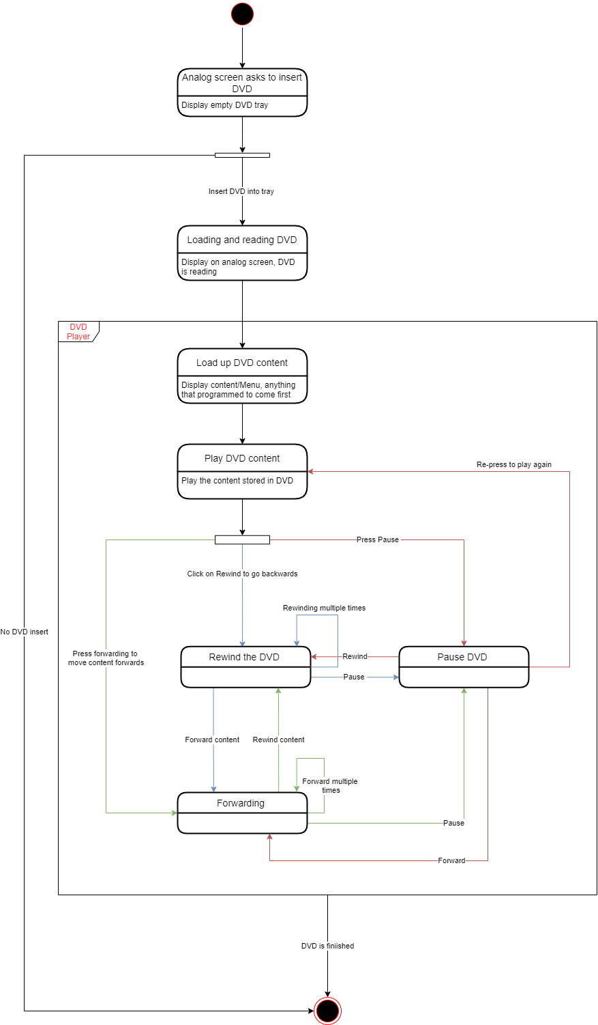

* A telephone answering system that records incoming messages and displays the number of accepted messages on an LED. The system should allow the telephone customer to dial in from any location, type a sequence of numbers (identified as tones), and play any recorded messages